**MFM E-System: QR Code Verification of points calculation for tax deduction and Discount Management of Manolo Fortich Municipality**

A Capstone Project

Presented to the

Faculty of the College of Computer Studies

Northern Bukidnon State College

In Partial Fulfillment

of the Requirements for the Degree

Bachelor of Science in Information Technology

By

COLLANTES, HAZEL JOY E.

OLBINAR, LORCHEEN C.

REMETICADO, JHON DAVE S.

SUMOHOY, BERNADITH N.

November 2024

**APPROVAL SHEET**

This Capstone Project entitled: **“MFM E-System: QR Code Verification of points calculation for tax deduction and Discount Management of Manolo Fortich Municipality”** is prepared and submitted by **Hazel Joy E. Collantes, Lorcheen C. Olbinar, Jhon Dave S. Remeticado, Bernadith N. Sumohoy** in partial fulfillment of the requirements for the degree of **Bachelor of Science in Information Technology** has been examined and is recommended for acceptance and approval.

**CLIFF AMADEUS F. EVANGELIO**

Adviser

**PANEL OF EXAMINERS**

Approved by the Committee on Oral Examination with a grade of ______________ on November 14, 2024.

**SHIELA MAE M. OROZCO, MSIT**

Chairman

**ZICHRI A. VICARIATO**

Member

**MITZI CLYDE S. TURTOR**

Member

**ROLAND JUSTINE M. PARTOS**

Member



Approved and accepted in partial fulfillment of the requirements for the degree Bachelor of Science in Information Technology

**SHIELA MAE M. OROZCO** **, MSIT**

Program Head

**ACKNOWLEDGMENT**

In the name of our almighty God, the most gracious and the most merciful for giving the researchers strength, knowledge, ability, and opportunity for letting the researchers work on the capstone project despite all the difficulties and challenges the researchers have experienced your guidance day by day, you are the one who let the researchers finish the degree, the researchers will keep on trusting you for the researcher’s future.

Secondly, the researchers would like to thank the panelists Sir Zichri A. Vicariato, Maam Mitzi Clyde S. Tutor and Sir Roland Justine M. Partos for giving the researchers a great chance to finish the researchers’ studies despite the problems in the systems. The panelists enlighten the researchers minds to take that advice, comments, suggestions, and guidance in completing this dissertation. The researchers are thankful to the department head Ms. Shiela Mae M. Orozco, for providing facilities to carry out the researcher’s capstone project work.

The researchers thankfully acknowledge the continuous support and inspiration that the researchers received from dear adviser, Mr. Cliff Amadeus Evangelio for his patience, motivation, enthusiasm, and immense knowledge to guide and help the researchers from the first day until the researchers reach the day that the researchers need to work the system fully. Thank you for the guidance and help, without you Sir the researchers will not be able to finish the capstone project.

The researchers would also like to give special thanks to all classmates, and friends for spending free time helping the researchers to make the papers, and system and to share the gifts to make them laugh and feel comfortable despite the researcher’s tiredness and stress.

And lastly, the researchers are grateful to their parents for the love, prayers, caring, sacrifices, understanding, continuing support, and also wisdom to make all things possible.

The Researchers

**ABSTRACT**

Manolo Fortich Municipality plan a program to used tax credit points program to provide subsidies for farmers and encourage businesses to participate in the program, businesses that gives discount to registered farmers will be tax credit, every 1 peso discount will be equivalent to 1 peso tax credit points earn, up to 10,000 a year for every qualified registered farmers. This will be divided biannually, first half a year will be given 5,000 and 5,000 in the second half. Tax credit will be supplied by the LGU’s subsidies to farmers, this program will benefits the MAO in implementing subsidies for farmers, while the current programs takes much work, like storage, tracking, manpower and time consuming for providing seeds and fertilizers subsidies to farmers,while this tax credit program will eliminate the load of work by the MAO office by encouraging businesses to participate in the program by giving them tax credit or incentives. Now businesses see the potential risk participating in the program in a traditional way, doing manual validation and paper works will be prone to manipulations, fraud and loads of work, so they seek for security and assurance, so MFM E-System: QR Code Verification of points calculation for tax deduction and Discount Management of Manolo Fortich Municipality addresses all the potential risk. The use of QR codes for secure and efficient verification has also proven useful in other systems, boosting tracking and data management while providing high security. Inventory management systems can aid with transaction processing and data management in discount programs. Using a web-based system to simplify processes and minimize staff workload has been proved to improve efficiency and service quality in different settings. The researchers introduce MFM E-System, an automated solution that includes QR code verification and digital discount administration. This method is intended to simplify operations, improve accuracy, and raise the overall efficacy of the program. The MFM-E-System uses modern technology and concepts from web-based platforms to eliminate previous challenges, assure proper implementation, and achieve the program's goals more efficiently. The researchers develop a prototype model to provide the fundamentals and output of the system, covering the two (2) major crops being farm by farmers in the municipality of manolo fortich which are cassava and corn. The researchers do testing and surveys to improve and provide a better system. Due to System Portability Scale (SPS), System Reliability Scale(SRS), and System Usability Scale (SUS) evaluation results, with average satisfaction rated as 4.26 or equivalent to “Excellent”, researchers found out that stakeholders of the MFM-E-System have an interest in using the system in the discount and tax credit program. Therefore, in future goals, if the system would improve with more crops covered, not only focus on crops like corn and cassava, then all farmers, businesses and the LGU’s in Manolo Fortich will look forward to being part of the system.

**Keywords:** *Automated system, Business incentives, Cassava and corn, Data security, Discount management, Discount program, Digital administration, Efficiency improvement, Expanded crop coverage, Fraud prevention, Inventory management, LGU subsidies, MFM E-System, Manolo Fortich Agricultural Office (MAO), Manolo Fortich Municipality, Operational accuracy, Program efficacy, QR code verification, Subsidies for farmers, Tax credit points, Web-based platform*

**TABLE OF CONTENTS**

**Page**

**TITLE PAGE**  **i**

**APPROVAL SHEET ii**

**ACKNOWLEDGMENT iii**

**ABSTRACT v**

**TABLE OF CONTENTS** **vi**

**LIST OF FIGURES** **ix**

**LIST OF TABLES x**

**CHAPTER**

1 **THE RATIONALE** **1**

1.1 Introduction 1

1.2 Statement of the Problem 3

1.3 Objectives of the Study 4

1.4 Scope and Limitations of the Study 5

1.5 Significance of the Study 5

1.6 Definition of Terms 6

**2 REVIEW OF RELATED LITERATURE AND STUDIES** **8**

2.1 Related Literature and Studies 8

2.2 Synthesis of the Reviewed Related Literature and Studies 17

**3 METHODOLOGY** **18**

3.1 Research Design 18

3.1.1 Type of Research 18

3.2 Research Design Approach 19

3.3 Hardware and Software Specification 23

3.3.1 Hardware Development Specification 23

3.3.2 Software Development Specification 27

3.3.3 Hardware Deployment Specification 28

3.3.4 Software Deployment Specification 29

3.4 System Architecture 30

3.5 System Diagrams 31

3.6 System Evaluation 32

3.6.1 Evaluation Tool 38

3.6.2 Distribution of Respondents 39

**4 RESULTS AND DISCUSSIONS**  **40**

4.1 ISO Results 40

4.2 Overall Results 48

**5 SUMMARY OF FINDINGS, CONCLUSION 49**

**AND RECOMMENDATION**

5.1 Summary of Findings 49

5.2 Conclusion 50

5.3 Recommendation 51

**REFERENCES 52**

**APPENDICES 54**

A Project Team Assignment Form 54

B Preproposal Statement 55

C Project Working Title Form 56

D Revision List 57

E. Certification of Proofreading 59

F Gantt Chart 60

G Documentation 61 H ISO/IEC 25010 Evaluation Sheets 63

I User’s Manual 68

**CURRICULUM VITAE** 69

**LIST OF FIGURES**

**Figures Title Page**

1 Agile Development 19

2 System Design Architecture 30 3 Use-Case Diagram 31

4 Testing and Briefing 32

5 BSIT Logo as Marker 33

6 BSIT Logo 3D 34

7 Prompt to redirect user to the department he wants 35

8 Existing Website of NBSC 36

9 Finished Presentation Pictorials 36

10 Gathering of Feedback through Evaluation 37

11 Overall Quality Testing Graph 48

**LIST OF TABLES**

**Tables Title Page**

1 Hardware Development Specification 23

2 Software Development Specifications 27

3 Hardware Deployment Specifications 28

4 Software Deployment Specifications 29

5 Likert Scale Table 38

6 Distribution of Respondents 39

7 Functionality Suitability 40

8 Performance Efficiency 41

9 Compatibility 42

10 Usability 43

11 Reliability 44

12 Security 45

13 Maintainability 46

14 Portability 47

CHAPTER 1

**THE RATIONALE**

* 1. **Introduction**

Manolo Fortich is a town in Bukidnon, Philippines, known for its rich history and farming heritage. It covers 506.64 square kilometers and is divided into 22 barangays. It has a population of 113,200 (census 2020). The town is home to 4,115 farmers who grow crops like cassava, corn, bananas, and coffee, showing its strong agricultural background according to the Municipal Agriculture Office (MAO). Despite its farming potential, these farmers struggle to get essential supplies such as seeds and fertilizers due to high costs . The Municipality of Manolo Fortich LGU specially the Municipal Agriculture Office (MAO) has long been dedicated to supporting local farmers by creating programs to help them access agricultural products such as seeds and fertilizers. Despite their efforts, past initiatives have struggled to achieve the desired outcomes due to various challenges. To address these issues, the LGUs, such as the Municipal Agriculture Office (MAO) and Business Permit and Licensing Office (BPLO), planned and designed a new discount program aimed at providing farmers with better access to essential agricultural supplies. This program also offers tax credits, using subsidies, to incentivize businesses that support the initiative.

MFM-E-SYSTEM uses a QR Code Verification for registered farmer buyers, it also has Point of Sale and Inventory for the store. It optimizes the process by calculating the discount allocated to each confirmed farmer as credit points, which may be utilized to reduce their annual tax obligations. Additionally, it assists farmers in obtaining discounts on their agricultural necessities. This System was designed and Planned accordingly Based on investigation and research, private stores like (Alomah's nature farm) at Dahilayan and GVA Enterprise in tankulan manolo fortich), Speaks about the significant risks and challenges in implementing this program manually. The manual processes have proven problematic, including difficulties with verification and transaction management, which will slow down the effective rollout of the program (Nagel, Stone, & McAdams, 2007).

The use of QR codes for secure and efficient verification has also been effective in other systems, improving tracking and data management with strong security features (Al Amin et al., 2024). Also, applying principles from inventory management systems can help improve transaction processing and data management for discount programs (Kambivi et al., 2020). Also, using a web-based system to make operations easier and reduce staff workload has been shown to enhance efficiency and service quality in other contexts (Tubongbanua et al., 2017). These findings support the Study move to a new approach. The researchers introduce an automated solution with QR code verification and digital discount management called MFM E-System. This system is designed to make operations simpler, improve accuracy, and increase the entire effectiveness of the program. By using modern technology and ideas from web-based systems, the MAO aims to solve past problems, ensure correct implementation, and achieve the program’s goals more effectively.

This study is backed by several important Philippine laws and regulations aimed at boosting investment and economic growth. Key laws include the Omnibus Investments Code of 1987 (Executive Order No. 226), the Bases Conversion and Development Act of 1992 (RA 7227), and the Special Economic Zone Act of 1995 (RA 7916). Other related laws include the Zamboanga City Special Economic Zone Act of 1995 (RA 7903) and the Cagayan Special Economic Zone Act of 1995 (RA 7922), as well as the Aurora Pacific Economic Zone and Freeport Act of 2007 (RA 9490) and the Freeport Area of Bataan Act of 2009 (RA 9728). Additional laws like the Regional or Area Headquarters, Regional Operating Headquarters and Regional Warehouses Act (RA 8756), the Export Development Act of 1994 (RA 7844), and the Tourism Act of 2009 (RA 9593) also support business and export growth, and aim to boost tourism. Following these national guidelines, Manolo Fortich has enacted Ordinance No. 2020-1345, which establishes the "Local Investment and Incentive Code of the Municipality of Manolo Fortich." This ordinance aims to create a friendly business environment by providing financial and other incentives to attract and keep both local and foreign investors. The goal is to boost economic development, create jobs, increase revenue, reduce poverty, and improve the quality of life in the town (ORDINANCE NO. 2020-1345, 45th Regular Session). This code is all about making Manolo Fortich a more attractive place for businesses to invest, grow, and create jobs, while also ensuring that the benefits align with the community's goals for future development (Local Investment and Incentive Code, 2020). Subsidies can play a crucial role in supporting market players and improving program outcomes by addressing market failures and encouraging participation (Barnedo & Inocencio, 2021). Additionally, well-designed financial incentives can boost engagement and effectiveness (Bansal & Gangopadhyay, 2003).

The "MFM E-System: QR Code Verification of Points Calculation for Tax Credit and Discount Management of Manolo Fortich" study will look at how using modern technology, like QR codes, can simplify the verification process and make the discount program more efficient. This approach aligns with the laws and policies to support local economic development and effectively address the challenges faced by farmers in Manolo Fortich.

* 1. **Statement of the Problem**

The LGU’s of Manolo Fortich like Municipal Agriculture Office (MAO) and Business Permit and Licensing Office (BPLO) may encounter difficulties implementing a discount program for farmers without a computerized approach, as human processes will lead to diminished productivity and susceptibility to manipulation. First verification hassles arise as store employees must manually check each farmer's registration by reviewing paper records or contacting the Municipal Agriculture Office MAO. This slow and error-prone process, compounded by the distance between the Municipal Agriculture Office MAO and stores when online communication is unavailable, often results in farmers missing out on discounts. Second fraud risks include people pretending to be registered farmers to get discounts. This type of fraud, such as fake or “ghost” farmer purchases, can lead to financial losses and damage trust in the program. Also, stores might manipulate the discounts to earn more points and avoid their tax responsibilities, further complicating the issue. Lastly the project implementation problems arise because many stores are hesitant to join the discount program. Manual verification is too complicated and risky, making them worried about fraud and wasting time. This reluctance hurts the overall success of the program.

* 1. **Objectives of the Study**

The main objective is to create an automated system for managing discounts and calculating points for tax deductions at the Manolo Fortich Agricultural Office (MAO). This system will make it easier and faster to handle discounts farmers and verify farmers information.

* To gather information through conducting interviews, surveys, research, and investigations to collect data from farmers and private stores in Manolo Fortich about their current experiences and challenges with the discount program and manual verification processes, while also reviewing relevant laws and regulations affecting these processes.
* To analyze the gathered data, see the laws that back up the government program and integrate the new technology, such as web-based systems, QR codes, POS and Inventory tools.
* To design the system by creating features based on the analyzed data to ensure the system securely verifies identities, manages discounts, and calculates tax points accurately.
* To develop the system by building it using technologies like PHP, HTML, CSS, JavaScript, and MySQL to ensure it is functional, user-friendly, and able to handle all necessary tasks effectively.
* To test the system Using standard testing methods, including System Usability Scale standards to ensure it meets quality and security requirements.
* To deploy the system, set it up at the Manolo Fortich Agricultural Office according to local regulations. Provide thorough training and clear user manuals to help staff transition smoothly from the old manual methods to the new automated system.
* To review the feedback during deployment and testing phases and Start the Cycle of the improved version by the future researchers.

**1.4 Scope and Limitations of the Study**

**Scope**

The MFM E-System is a web-based tool that helps manage agricultural discounts and calculates points for tax credits at the LGU’s of Manolo fortich like Manolo Fortich Agricultural Office (MAO) and Business Permit and Licensing Office (BPLO). The system fastens the process of verifying farmer registrations, managing discount applications, calculating tax credit points, where each point earned equals the value of the discount given, up to 10,000 a year for every qualified registered farmer. This will be divided biannually, first half a year will be given 5,000 and 5,000 in the second half. Tax credit will be supplied by the LGU’s subsidies to farmers, Admins can also monitor and manage agricultural product prices set by stores with the ability to update or approve them as needed. ensure accuracy and prevent fraud, the system uses QR codes for authentic and secure verification. It includes a Point of Sale (POS) system to handle transactions and track discounts in real-time, The system includes branch management, product inventory management, and employee management features to help store owners effectively manage branches, product stocks, and store employees. The system also tracks and displays location the distance between farmers and participating stores. This study will cover the design, development, and deployment of the system, along with providing training and support materials. The researchers will measure the system’s success by how well it simplifies processes, improves accuracy, and enhances overall efficiency.

**Limitations**

The web-Based application uses simple design, No Online hosting in the current, no physical receipt, no online payment, no third party integration, no online hosting, uses phone camera only for scanning QRcode, and Currently No online hosting, but can be added when the project will be implemented.

**1.5 Significance of the Study**

The MFM E-System, a web-based platform for managing agricultural discounts and calculating tax credit points at the Manolo Fortich Agricultural Office (MAO), is important for several key groups:

**To Manolo Fortich Agricultural Office (MAO).** The MFM E-System shows that the MAO is committed to improving its processes and supporting local farmers through modern technology. By using this system, the MAO can better manage discounts and track tax credit points, enhancing its reputation and effectiveness in helping farmers.

**To Farmers.** Farmers will benefit from easier access to discounts on agricultural products. The system simplifies the process of verifying their registration and applying discounts, making it more straightforward for them to get the support they need.

**To Store Owners.**The system helps store owners by making it easier to verify farmer registrations and apply discounts accurately. It also provides a way to earn points based on the discounts they give, which can lead to potential rewards or bonuses, improving their involvement and support for the program.

**To LGU’s (MAO and BPLO) Staff.** The system improves how LGU’s staff manage and track discounts and tax credit points. It automates many of their tasks, reduces errors, and helps them work more efficiently, allowing them to focus on other important duties.

**To Future Developers.** Creating and implementing the MFM E-System gives developers valuable experience with web-based systems for managing discounts and calculating tax points. The project offers insights into solving real-world problems with technology, helping them build skills and knowledge for future projects.

**To Future Projects.** This study provides a useful example for future work on similar systems. By documenting how the MFM E-System was developed and used, it can guide and inspire others working on projects to improve agricultural support and discount management.

**1.6 Definition of Terms**

**MFM E-System.** A web-based platform developed to manage agricultural discounts and calculate tax credit points for the Manolo Fortich Agricultural Office (MAO). The system automates farmer verification, manages discount applications, and tracks points for tax deductions.

**Agricultural Discounts.** Price reductions on agricultural products such as seeds and fertilizers provided to registered farmers. These discounts are managed through the MFM E-System and are intended to support farmers by lowering their costs.

**Tax Credit Points.** Points calculated based on the value of the discounts given to farmers. These points can be used by stores to reduce their annual taxes. The MFM E-System calculates and tracks these points.

**QR Code Verification.** A method of using QR codes to securely and quickly verify farmer registrations. Farmers receive a unique QR code that store employees scan to confirm their registration status.

**Manual Verification.** The traditional process of checking farmer registrations and applying discounts through physical records, phone calls, or in-person visits. This process is slower and more prone to errors compared to automated methods.

**Integration.** The process of connecting the MFM E-System with existing databases and systems at the MAO to ensure seamless data sharing and management.

**User Interface.** The part of the MFM E-System that users interact with. It includes the design and layout of the system, making it easier for store employees and MAO staff to use the system effectively.

**Store Owners.** Businesses that sell agricultural products and are involved in providing discounts to registered farmers through the MFM E-System. They use the system to manage discounts and earn tax credit points.

**Farmers.** Individuals who grow crops or raise livestock are registered with the MAO to receive discounts on agricultural products. They benefit from the system through easier access to discounts and support.

**Administrative Operations.** The tasks and processes carried out by MAO staff to manage and oversee the discount program and tax credit points. The MFM E-System aims to improve the efficiency of these operations.

**CHAPTER II**

**REVIEW OF RELATED LITERATURE**

**2.1 REVIEW OF RELATED LITERATURE OF THE STUDY**

The related literature of the study highlights a number of important factors that align with and strengthen the objectives of the "MFM E-System: QR Code Verification of Points Calculation for Tax Credit and Discount Management of Manolo Fortich." These studies emphasize the importance of technology, incentives, and secure systems in improving program effectiveness, which represents in contrast to the traditional manual processes that the MFM E-System aims to address.

Financial Incentives and Participation, (Bansal and Gangopadhyay 2003) emphasize the role of well-designed financial incentives in boosting participation and program effectiveness. This aligns with the core objective of the MFM E-System, which leverages discounts as incentives for both farmers and stores to participate in the program. The use of a tax credit system within the MFM E-System adds a structured financial incentive, encouraging broader participation and ensuring the program's sustainability. In contrast, the traditional method lacks this structured financial approach, often relying on one-off incentives that may not be enough to engage stakeholders long-term. The QR Code-driven automation in MFM E-System ensures that participants can track their discounts and tax credits easily, making the incentives more tangible and reliable.

Subsidies and Addressing Market Failures, (Barnedo and Inocencio 2021) discuss how subsidies can help address market failures and encourage participation. The MFM E-System, by automating discounts and making them easier to claim through the use of QR codes, similarly seeks to overcome inefficiencies in the current system. It ensures that genuine farmers can quickly and securely access subsidies in the form of discounts, which were previously prone to delays and fraud due to manual verification processes. Contrasting with the traditional ways, where verification challenges and geographical barriers caused inefficiencies, the MFM E-System's automated process eliminates many of these hurdles. It streamlines participation, making subsidies more accessible and effectively addressing market failures that hindered growth and engagement.

Technology for Security and Tracking the use of QR codes for verification is supported by (Al Amin et al., 2024), who demonstrate how technology can enhance tracking and security. This is crucial for the MFM E-System, as it ensures that registered farmers can be easily and securely verified, reducing fraud and manipulation of discount claims. Previously, the conventional verification system was prone to errors and fraud, such as the potential for "ghost" farmers to exploit the program. The introduction of QR code-based verification increases security, providing a level of transparency and trust that was not possible before.

Trust and Transparency through Secure Systems,advantages of blockchain technology in creating secure and transparent systems, which improve trust and efficiency, are highlighted in recent studies (Panda et al., 2021) and (Ti, Chen, & Wu, 2020). While the MFM E-System does not use blockchain, its use of digital records and QR codes ensures transparency and accountability in the point calculation and discount management process. This makes it easier for both the farmers and the government to track transactions and ensure accurate application of discounts and tax credits. The manual system, on the other hand, often suffered from trust issues due to the lack of transparency, leading to hesitancy among stores and farmers to fully engage with the program. The MFM E-System improves this by introducing traceable digital records, thus building trust between participants.

Efficiency and Data Management, (Kambivi et al., 2020), (Chinyere & Ikoromamsoma, 2021) and (Qi, Sun, & Hosseini, 2023) show how modern applications can improve efficiency and data management, which is directly relevant to the MFM E-System's goal of simplifying operations. The introduction of inventory management and real-time data tracking in the system helps stores manage supplies while keeping track of the discounts issued to farmers. The automation of point calculations and discount management improves accuracy and reduces human error, which was a major issue in the manual system. In contrast, the traditional method's manual data handling often led to inaccuracies, delays, and potential misuse, significantly slowing down the program's rollout and reducing its overall effectiveness.

The continuous growth of the business industry requires that organizations constantly improve the quality of their products and services. This dedication to continuous improvement is critical for achieving a competitive advantage, especially in terms of efficiency, effectiveness, performance, and business growth. Our research follows this trend by focusing on the creation of a Point of Sale (POS) management application specifically built to assist purchasing service systems and inventory management for small and medium-sized firms (SMEs). This is consistent with (Kambivi et al., 2020), who highlighted the necessity of POS systems for controlling sales transactions, inventories, and improving customer service. It illustrates that a well-implemented POS system can automate the tasks associated with inventory management, allowing business owners to maintain control over stock levels and streamline sales processes. This is particularly relevant for SMEs, where resources may be limited, and efficient data management can significantly impact overall performance. Our POS system employs a similar approach by integrating inventory management capabilities, thus assisting businesses in optimizing their operations and reducing risks associated with manual data handling.

(Dewi et al., 2021) highlight the importance of utilizing Agile development methodologies in the creation of POS systems. Agile emphasizes iterative development and client satisfaction, enabling quick adaptations to changing business needs. In our study, the researchers adopt Agile principles to ensure that the POS application remains user-friendly and responsive to the requirements of stakeholders, mirroring the success seen at InHome Café, which achieved a 96.15% success rate in system functionality testing.

The contrasting perspective presented by (Marico et al., 2021) provides valuable insights into the varying needs of businesses when selecting POS systems. Their research reveals that not all POS solutions are equally suitable for every business model, highlighting the necessity for a tailored approach. For instance, while open-source POS systems like E-hopper and Loyverse may cater to specific preferences regarding device usage and operational contexts, our application aims to integrate features that are adaptable for a broader range of SME scenarios. This adaptability is crucial in helping businesses transition from outdated manual systems to more efficient, tech-driven solutions. Our study demonstrates the importance of developing a strong POS system that incorporates inventory management capabilities using Agile development methodologies. By drawing on the insights from (Kambivi et al., 2020), (Dewi et al, 2021), and (Marico et al., 2021), we illustrate how our approach not only aligns with current industry trends but also addresses the unique challenges faced by SMEs in their pursuit of operational efficiency and competitive advantage.

The study "MFM E-System: QR Code Verification of Points Calculation for Tax Credit and Discount Management of Manolo Fortich" is closely aligned with several key laws and ordinances that support economic growth and business incentives. These laws provide a framework for encouraging investment, boosting local businesses, and supporting development initiatives. Here's a breakdown of how the referenced laws support this study:

Omnibus Investments Code of 1987 (Executive Order No. 226): This law promotes investments by offering tax incentives and benefits to businesses, which aligns with the MFM E-System’s goal of encouraging stores to participate by offering discounts to farmers. It complements the study’s approach to providing tax credits to stores that offer agricultural discounts.

Bases Conversion and Development Act of 1992 (RA 7227) and Special Economic Zone Act of 1995 (RA 7916): These laws establish economic zones to attract investments, providing special incentives similar to those the MFM E-System is aiming to offer to farmers and private stores. The idea of boosting local economies through financial incentives and tax breaks in economic zones directly supports the study’s goal of using discounts and points for tax credits to stimulate participation.

Zamboanga City Special Economic Zone Act of 1995 (RA 7903), Cagayan Special Economic Zone Act of 1995 (RA 7922), and Aurora Pacific Economic Zone and Freeport Act of 2007 (RA 9490): These acts establish special zones with incentives for development, mirroring the incentives for local stores in Manolo Fortich to engage in the discount program.

Freeport Area of Bataan Act of 2009 (RA 9728): This law emphasizes creating attractive business environments, similar to the goals of the MFM E-System, which seeks to improve the local agricultural economy by automating and incentivizing transactions with tax credit points.

Regional or Area Headquarters Act (RA 8756) and Export Development Act of 1994 (RA 7844): These laws support business development and export growth, which aligns with the broader economic goal of the MFM E-System to strengthen local businesses, including agricultural supply stores, by offering them incentives to participate in the program.

Tourism Act of 2009 (RA 9593): Although this law focuses on tourism, its emphasis on improving local economic conditions through incentives parallels the study’s focus on supporting local farmers and stores in Manolo Fortich.

Ordinance No. 2020-1345 (Local Investment and Incentive Code of the Municipality of Manolo Fortich): This ordinance specifically establishes a local framework to attract and retain businesses by offering incentives, which is at the core of the MFM E-System. The ordinance supports the creation of a friendly business environment, encouraging local stores to engage in the MAO discount program by offering tax credits for their participation.

While all of these national regulations aim to encourage investment through special zones and economic incentives in a variety of fields, the MFM E-System focuses on the agriculture industry in Manolo Fortich. It uses modern technology such as QR codes and web-based platforms to address specific issues linked to discount programs and tax breaks. The technology simplifies processes and tries to avoid fraud by guaranteeing that only confirmed farmers receive discounts and that businesses are rewarded for their involvement with tax credits, resulting in a more targeted and efficient approach. The MFM E-System complies with these regulations by promoting local economic growth through financial incentives and new technologies, particularly in the agricultural sector, so serving as a realistic extension of both national and municipal investment programs.

**2.2 Synthesis of Related Review Literature and Studies**

The above collection of related literature provided data that the present study, while resemblances have been seen with other systems, proponents position significantly larger interest in the research gaps discovered to produce creative ideas. As an outcome, the current proposal has an advantage over other studies on MFM E-System web applications.

According to the Financial Incentives and Participation Study for Tax incentives (Bansal and Gangopadhyay 2003). The role of well-designed financial incentives will boost participation and program effectiveness. subsidies can help answer market failures and encourage participation, based on the study Subsidies Addressing Market Failures, (Barnedo and Inocencio 2021). Technology for Security and Tracking the use of QR codes for verification is supported by (Al Amin et al., 2024), who demonstrate how technology can enhance tracking and security. Trust and Transparency through Secure Systems, advantages of blockchain technology in creating secure and transparent systems, which improve trust and efficiency, are highlighted in recent studies (Panda et al., 2021) and (Ti, Chen, & Wu, 2020). Efficiency and Data Management, (Kambivi et al., 2020), (Chinyere & Ikoromamsoma, 2021) and (Qi, Sun, & Hosseini, 2023) show how modern applications can improve efficiency and data management. management application specifically built to assist purchasing service systems and inventory management for small and medium-sized firms (SMEs). This is consistent with (Kambivi et al., 2020), who highlighted the necessity of POS systems for controlling sales transactions, inventories, and improving customer service. It illustrates that a well-implemented POS system can automate the tasks associated with inventory management, allowing business owners to maintain control over stock levels and increase sales processes. This is particularly relevant for SMEs, where resources may be limited, and efficient data management can significantly impact overall performance. The MFM E-System POS system employs a similar approach by integrating inventory management capabilities, thus assisting businesses in optimizing their operations and reducing risks associated with manual data handling. The MFM E-System, ensures that registered farmers can be easily and securely verified, reducing fraud and manipulation of discount claims. The MFM E-System, automates discounts and makes them easier to claim through the use of QR codes. It ensures that registered farmers can securely access subsidies in the form of discounts, which were previously prone to delays and fraud due to manual verification processes. The MFM E-System's automated process eliminates many of these hurdles. It encourages business participation, making subsidies more accessible and effectively addressing market failures that delays growth in Manolo Fortich Municipality.

**CHAPTER III**

**METHODOLOGY**

**3.1 Research Design**

**3.1.1 Type of Research**

The research design for the MFM E-System involves a structured approach to developing a system for managing agricultural discounts and calculating tax credits in Manolo Fortich, Bukidnon. The methodology integrates quantitative methods to thoroughly understand the needs and assess the effectiveness of the system.

**3.2 Research Design Approach**

The research design approach for the MFM E-System provides a clear framework for developing and implementing an agricultural discount and tax credit monitoring system in Manolo Fortich, Bukidnon. This approach ensures that the system effectively meets the needs of local farmers and enhances the management of agricultural discounts. The methodology follows an Agile approach, which includes the stages of requirements gathering, design, development, testing, deployment, and review.



**Figure 1.** Agile Development

Source : Agile Methodology in System Development source: Okeke(2021), retrieved from https://targettrend.com/agile-methodology-meaning-advantages

disadvantages-more

**REQUIREMENTS**

In the Requirements Phasethe researchers conduct a series of interviews on Municipality of Agriculture Office, Stores Like Alomahs Place using quantitative questions to gather data that will be needed in the study. Also the researchers gathered 20 related studies, Review Laws in Sangguniang Bayan Office that support Government Program and list of distributions of farmers and Crops to have a Strong foundation and reliable sources of Information to be used in the study. In this phase also the researchers make a series of consultations in their panels, advisers and coordinators for the feasibility of the study.

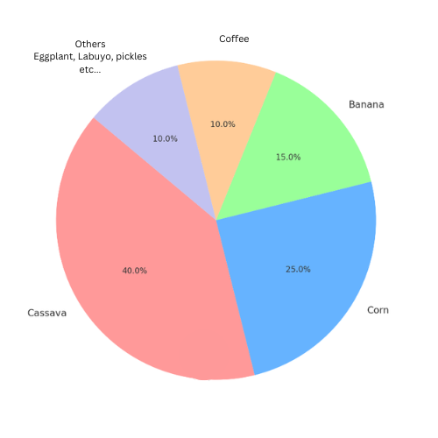

**Figure 2.** Agricultural Crops Distribution Matrix

Figure 2 shows that in Manolo Fortich, The agricultural environment is occupied by many different kinds of crops, with cassava accounting for 40% (1,646 farmers) of all crops grown. Corn is the second most planted crop, accounting for 25% (1,029 farmers) of the land. Bananas, which account for 15% (617 farmers), are also a prominent crop, as is coffee, which accounts for 10% (412 farmers). The remaining 10% (412 farmers) is attributed to various other crops.

Based on the distribution of crops in Manolo Fortich according to MAO during our interview, the researchers can estimate the demand for agricultural products such as seeds and fertilizers. Given that cassava, corn, and bananas make up the majority of the planted crops-accounting for 40% (1,646 farmers), 25% (1,029 farmers), and 15% (617 farmers) respectively-the highest demand for agricultural inputs is likely for products suited to these crops. Cassava, being the leading crop, will drive significant purchases of cassava-specific seeds and fertilizers. Corn and bananas will also contribute substantially to the demand for corresponding agricultural products. Additionally, the need for inputs for coffee and other diverse crops will further influence the market for agricultural supplies. Understanding this crop distribution helps in forecasting the most purchased products and aligning supply strategies with the needs of local farmers in the municipality of Manolo Fortich.

The Geographic and Demographic of Farmers in Manolo Fortich**,** the number of barangays, and the population of farmers versus non-farmers, giving a broad overview of the Municipality layout and population distribution.

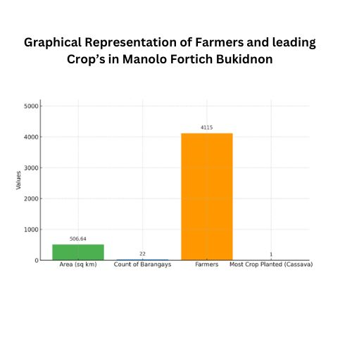

**Figure 3.** Geographic and Demographic Matrix

Figure 3 shows the farming scene in Manolo Fortich, an area of 506.64 square kilometers with 22 barangays. There are 4,115 farmers in the Municipality. Cassava is the most commonly grown crop, taking up the most space compared to others.

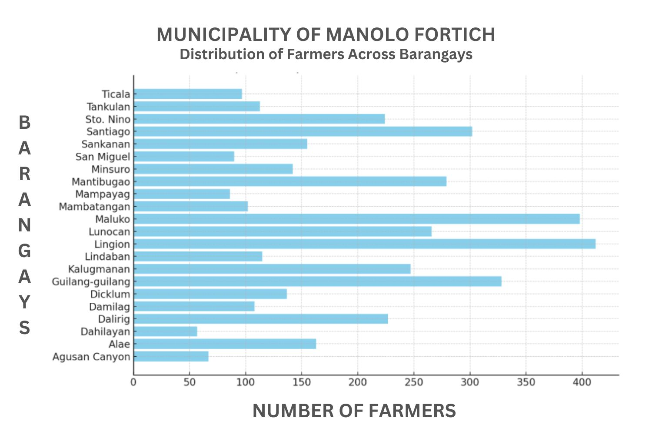

**Figure 4.** RSBSA Registered Farmers

Figure 4, the RSBSA Registered Farmers matrix represents the total number of farmers registered under the Registry System for Basic Sectors in Agriculture (RSBSA) within Manolo Fortich. The municipality has a total of 4,115 registered farmers, distributed across its 22 barangays. This geographic distribution highlights areas with higher concentrations of farmers, which are critical for implementing agricultural programs like the MFM E-System. The registration ensures that farmers can benefit from government support programs, such as agricultural discounts and tax deductions facilitated by the system. Registered farmers are verified through their unique QR codes, linking them to the system for accurate tracking of their transactions. The data from RSBSA not only supports the functionality of the MFM E-System but also ensures that only registered farmers can avail of its benefits, making the registry vital for its success.

The Population of farmers in Manolo Fortich, total population into farmers and non-farmers, offering insight into the proportion of the population involved in agriculture compared to other occupations.

**DESIGN**

In Design Phase the researchers Create a detailed plan and blueprint for the system based on the phase one the gathering of requirements, the researchers use the gathered information and analyze it to be used as a structural basis of the development stage, this part the researchers design the Ghanth Chart, system architecture, case diagrams, ERD and Context Diagram level 0.

**DEVELOPMENT**

In the Development Phase the researchers started Building the system according to the design specifications Using XAMPP, PHP, SQL, HTML, CSS, Javascripts and Bootstrap.

**TESTING**

In the Testing Phase the researchers Evaluate the system to identify and fix any issues or bugs. Also Conduct System Usability Scale for Users Evaluation.

**DEPLOYMENT**

In the Deployment Phase Implementing the system in a real-world environment and ensuring it operates effectively.

**REVIEW**

In this phase the researcher reviews all the feedback gathered in testing and deployment phases. this informations will be use for the second cycle of the system

**3.3 Hardware and Software Specification**

This section outlines the detailed specifications for the hardware and software required for both development and deployment phases of the system.

**3.3.1 Hardware Development Specification**

Specifications for the hardware components necessary for the development phase, including workstations, network equipment, and peripheral devices.

**Table 1.** Hardware Development Specification

| **Hardware** | **Specification** |
| --- | --- |
| Laptop Aspire A315-35 | Device name: LAPTOP-Aspire A314-35  Processor: Intel(R) Celeron(R) N4500 @ 1.10GHz 1.11 GHz  Graphics 2.40 GHz Installed RAM: 4.00 GB (3.81 GB usable)  System type: 64-bit operating system, x64-based processor  Pen and Touch: No pen or touch input is available for this display |

**3.3.2 Software Development Specification**

Specifications for the software tools and platforms required for developing the system, including development environments, frameworks, and libraries.

**Table 2.** Software Development Specification

| **SOFTWARE** | **SPECIFICATION** |
| --- | --- |
|  | **Version**: Varies (e.g., 8.2.4 for PHP 8.x)  **Processor**: Requires x86 or x64 processor  **System Requirements**: Windows, macOS, or Linux  **Installed RAM**: Minimum 512MB  **System Type**: 32-bit or 64-bit  **Description**: XAMPP is an open-source, cross-platform web server solution stack package that contains Apache HTTP Server, MariaDB, PHP, and Perl. It's primarily used for local development and testing of web applications. |
|  | **Version**: PHP 7.x or PHP 8.x  **Processor**: Compatible with x86 or x64 architecture  **System Requirements**: Compatible with Windows, macOS, and Linux  **Description**: PHP is a server-side scripting language designed for web development but also used as a general-purpose programming language. It is especially suited for creating dynamic websites and applications. |
|  | **Version**: CSS3 (latest version)  **Processor**: N/A (handled by web browsers)  **Description**: CSS is a stylesheet language used to describe the presentation of a document written in HTML or XML. It defines how elements are to be displayed, including layouts, colors, and fonts. |
|  | **Version**: ECMAScript 6+ (ES6, ES7, etc.)  **Processor**: N/A (interpreted by web browsers)  **Description**: JavaScript is a high-level, interpreted scripting language that enables dynamic interactivity on websites. It works alongside HTML and CSS to enhance user experiences. |
| VS Code | **Version**: Latest stable release (e.g., 1.68.x)  **Processor**: Requires x86-64 or ARM64 processors  **Graphics**: N/A  **Installed RAM**: 1 GB minimum  **System Type**: 32-bit or 64-bit  **Description**: VS Code is a lightweight but powerful code editor, available on Windows, macOS, and Linux. It includes features like debugging, embedded Git control, syntax highlighting, and intelligent code completion. |
|  | **Version**: HTML5 (latest version)  **Processor**: N/A (handled by web browsers)  **Description**: HTML is the standard markup language for creating web pages. It structures the web content and, when combined with CSS and JavaScript, forms the core technologies for building websites. |

**3.3.3 Hardware Deployment Specification**

Specifications for the hardware components necessary for the Deployment phase, including workstations, network equipment, and peripheral devices.

**Table 3.** Hardware Deployment Specification

| **Hardware** | **Specification** |
| --- | --- |
| Laptop Aspire A315-35 | Device name: LAPTOP-Aspire A314-35  Processor: Intel(R) Celeron(R) N4500 @ 1.10GHz 1.11 GHz  Graphics 2.40 GHz Installed RAM: 4.00 GB (3.81 GB usable)  System type: 64-bit operating system, x64-based processor  Pen and Touch: No pen or touch input is available for this display |
| Smart Phone | * GPU: Mali-G57 MP2 * Cores: 8 * Clock: 2400 MHz * Exynos 7870 * 144731 * 172 / 492 * 8 (8)1600 MHz * Mali-T830 MP1 * 4G - 5G internet |

**3.3.4 Software Deployment Specification**

Specifications for the software tools and platforms required for developing the system, including Deployment environments, frameworks, and libraries.

**Table 4.** Software Deployment Specification

| **SOFTWARE** | **SPECIFICATION** |
| --- | --- |
|  | **Version**: Varies (e.g., 8.2.4 for PHP 8.x)  **Processor**: Requires x86 or x64 processor  **System Requirements**: Windows, macOS, or Linux  **Installed RAM**: Minimum 512MB  **System Type**: 32-bit or 64-bit  **Description**: XAMPP is an open-source, cross-platform web server solution stack package that contains Apache HTTP Server, MariaDB, PHP, and Perl. It's primarily used for local Deployment and testing of web applications. |
|  | **Version**: PHP 7.x or PHP 8.x  **Processor**: Compatible with x86 or x64 architecture  **System Requirements**: Compatible with Windows, macOS, and Linux  **Description**: PHP is a server-side scripting language designed for web Deployment but also used as a general-purpose programming language. It is especially suited for creating dynamic websites and applications. |
|  | Stable release(s) [±]  Written in C, C++, Assembly, HTML, Java (Android app only), JavaScript, Python  Engines Blink (WebKit on iOS), V8 JavaScript engine  Operating system Android Oreo or later ChromeOS iOS 16 or later Linux macOS 11 or later Windows 10 or later  Platform IA-32, x86-64, ARMv7, ARMv8-A |

**3.4 System Design Architecture**

The system design architecture outlines the structure of the MFM E-System for managing agricultural discounts and tax credits. It includes the main components of the system and how they interact with each other. A high-level diagram will be created to illustrate this architecture, showing how features such as QR code verification, discount management, and tax credit calculations are integrated to support the needs of the Manolo Fortich Agricultural Office and private stores.

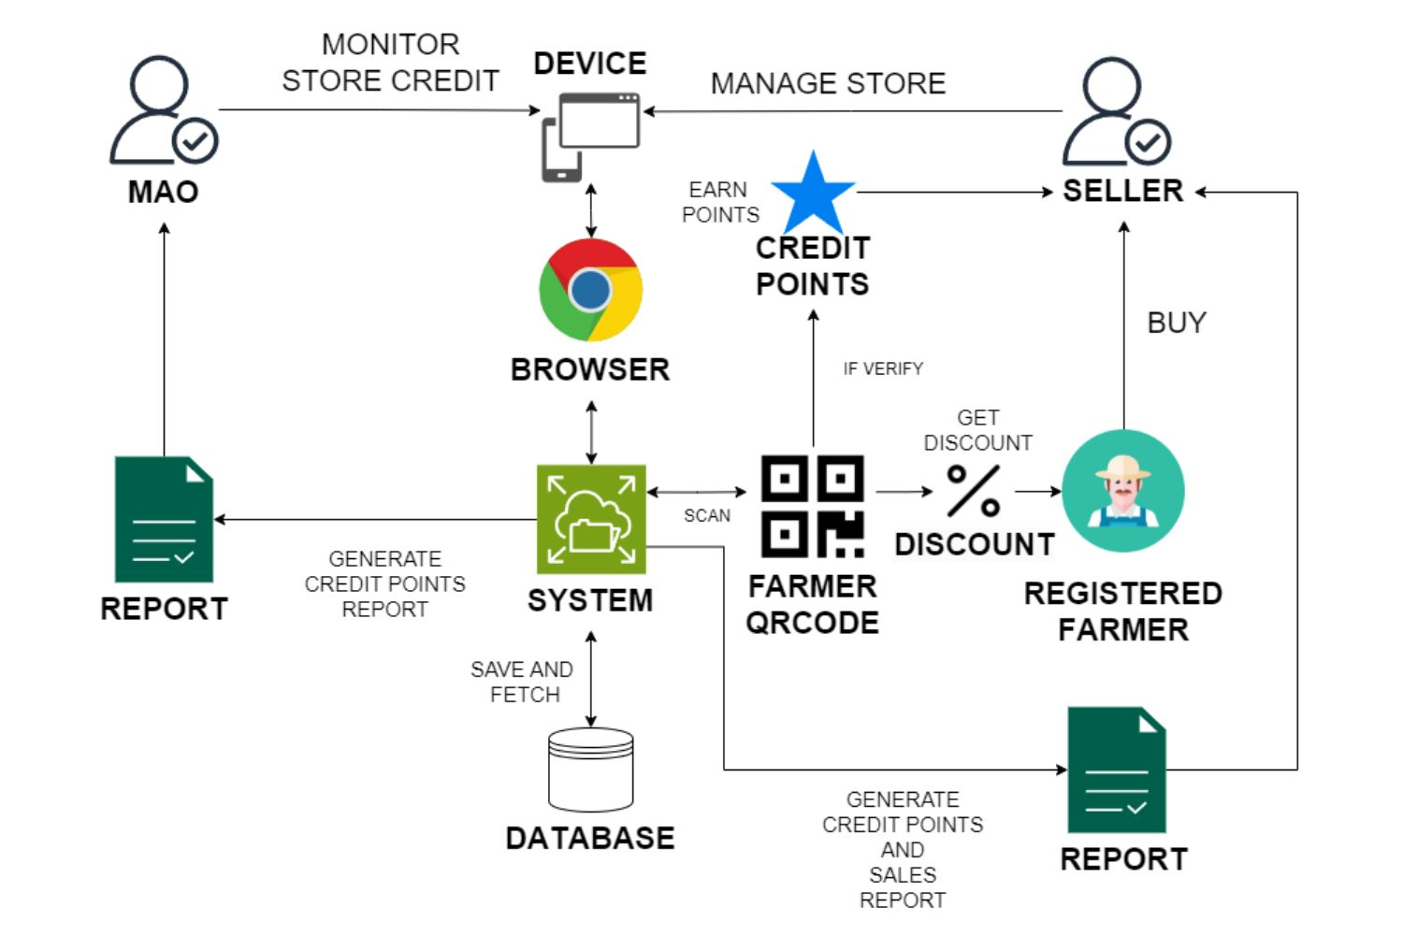

**Figure 5**. System Architecture

In Figure 5, the detailed flow of the MFM E-System is outlined. When a farmer purchases agricultural products from a participating store, they present their ID with a QR code to claim a discount. The store owner scans the QR code using the system, which verifies its validity and applies the discount. The system then automatically calculates the discount amount and the points earned by the store. It also functions as a Point of Sale (POS) system, managing the sale and updating the store's inventory in real-time. At the end of the year, the system generates reports showing the total points earned by each store, which are used for calculating tax credits. MAO administrators use the system to monitor and manage the process, ensuring smooth operations and accurate record-keeping.

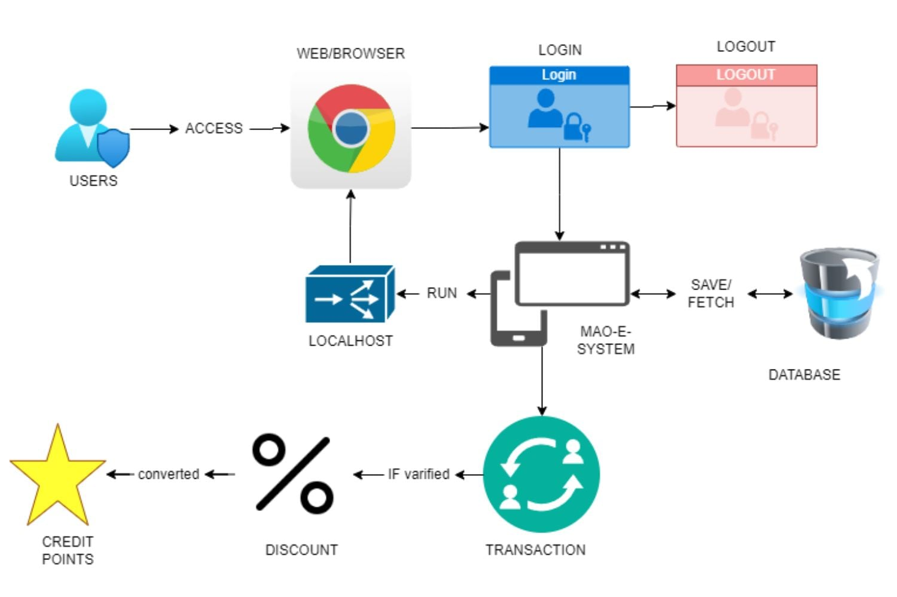

**Figure 6 .** Web-basedSystem architecture

Figure 6, illustrates a web-based architecture for the “MFM E-System,” designed for QR code verification related to points calculation for tax deductions and discount management in Manolo Fortich. Users access the system through a web browser, such as Google Chrome, and log in using a secure login process. The system operates on local servers, which interact with the central MFM E-System. This core system handles the main processes, including saving and fetching data from a database. Credit points earned by users are converted into discounts, and these discounts are verified before being applied to transactions. This ensures that users can securely log in, access their points, and manage discounts efficiently through a web-based interface.

**3.5 System Diagrams**

**Case Diagram**

The use-case diagram illustrates the interactions between users and the system. It helps in understanding the system's functionality and identifying the different user roles.

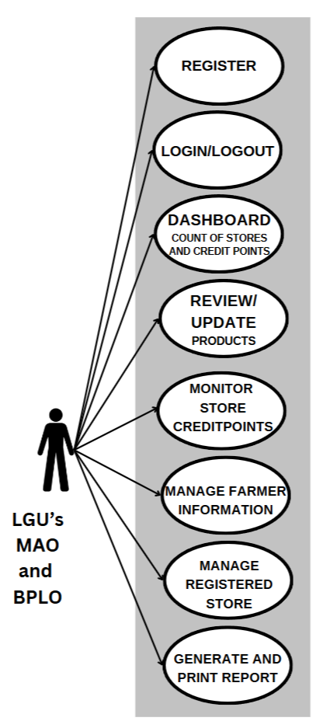

**Figure 7.** Used-Case Diagram for Admins MAO and BPLO

In Figure 7, the case diagram for the MFM E-System shows how Admin users interact with the system. The diagram starts with the Register/Login/Logout functions, allowing users to securely access their accounts or log out. From the Dashboard, can review stores credit points earned, review and update products set by the stores, manage farmers, manage registered stores and Generate reports.

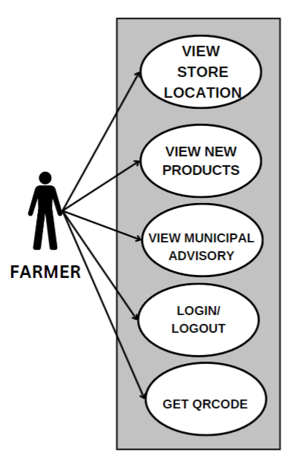

**Figure 8.** Used-Case Diagram for Farmer

Figure 8, the farmer-cased diagram shows the farmer benefits from the system,, can view the location of stores that participate in the program, view the products information for each store, login and logout and get the QRcode to be used in purchasing agri products.

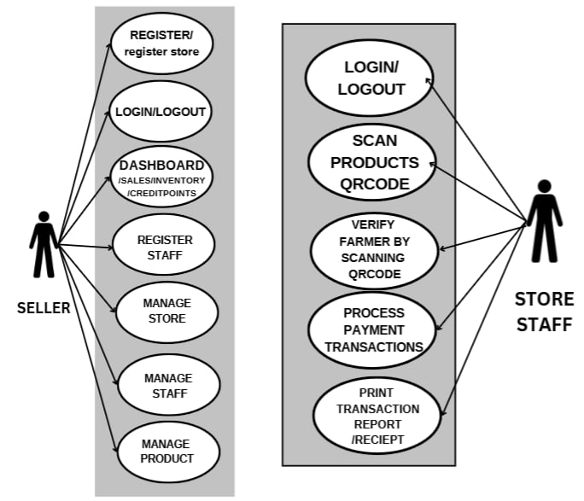

**Figure 9.** Used-Case Diagram for Seller and store-staff.

Figure 9, show that the seller can register, login and logout, can view store branches, sales, and low products, register and manage store, register and manage staff and also register and manage products, while the staff can also login and logout, scan products qrcode, verify farmer by scanning qrcode, process payment transaction and generate report.

**Entity Relationship Diagram**

The Entity Relationship Diagram (ERD) provides a graphical representation of the entities within our system and the relationships between them.

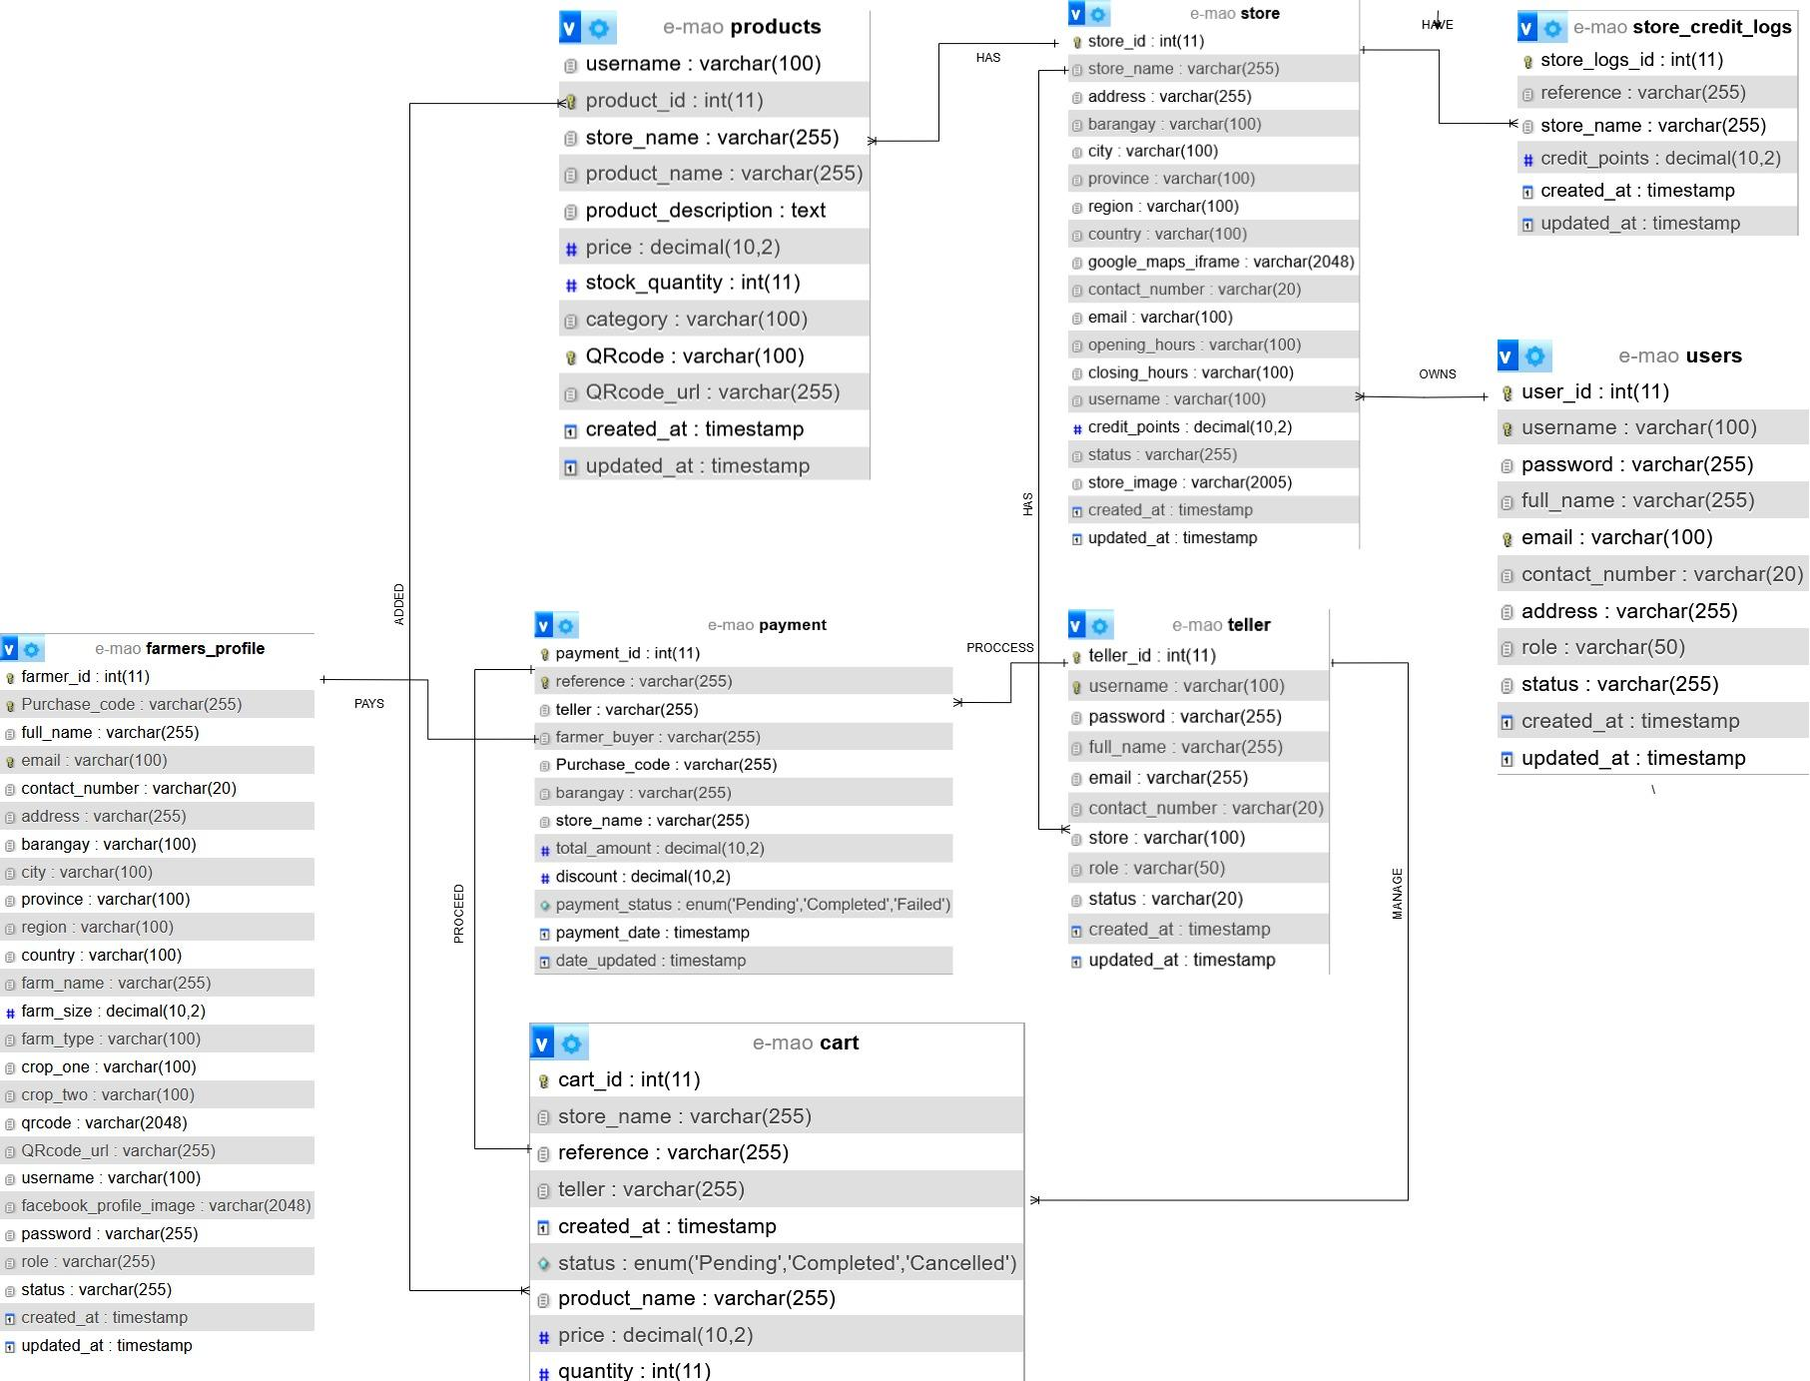

**Figure 10.** Entity Relationship Diagram

Figure 10 shows the ERD of the MFM E-System. There are seven entities: User, Store, store-staff, Farmer Profile, Product, Cart, and Payment. The relationship between User and Store is one-to-many, meaning a single user can own multiple stores. Within a single store, there are multiple products, indicating a one-to-many relationship between Store and Product. A store also has many store-staff, so the relationship between Store and store-staff is one-to-many. In a cart, multiple products can be ordered, and a single product can be added to multiple carts, resulting in a many-to-many relationship between Cart and Product. A store-staff can process multiple carts, indicating a one-to-many relationship between store-staff and Cart. Lastly, each cart can be transacted only once, establishing a one-to-one relationship between Cart and Payment.

**3.6 System Evaluation**

**Deployment**

The following procedures were taken by the researchers as the application is ready to deploy.

*Testing and Briefing*

Prior to the testing and briefing, the researchers scheduled a presentation and demonstration, which included system testing and briefing. During the presentation, the researchers initially performed testing and briefed the users, as illustrated in Figure 11. During the testing and briefing portion of the demonstration, the researchers showed the system to the participants so that they could understand how it works.



Figure 11. Testing and Briefing

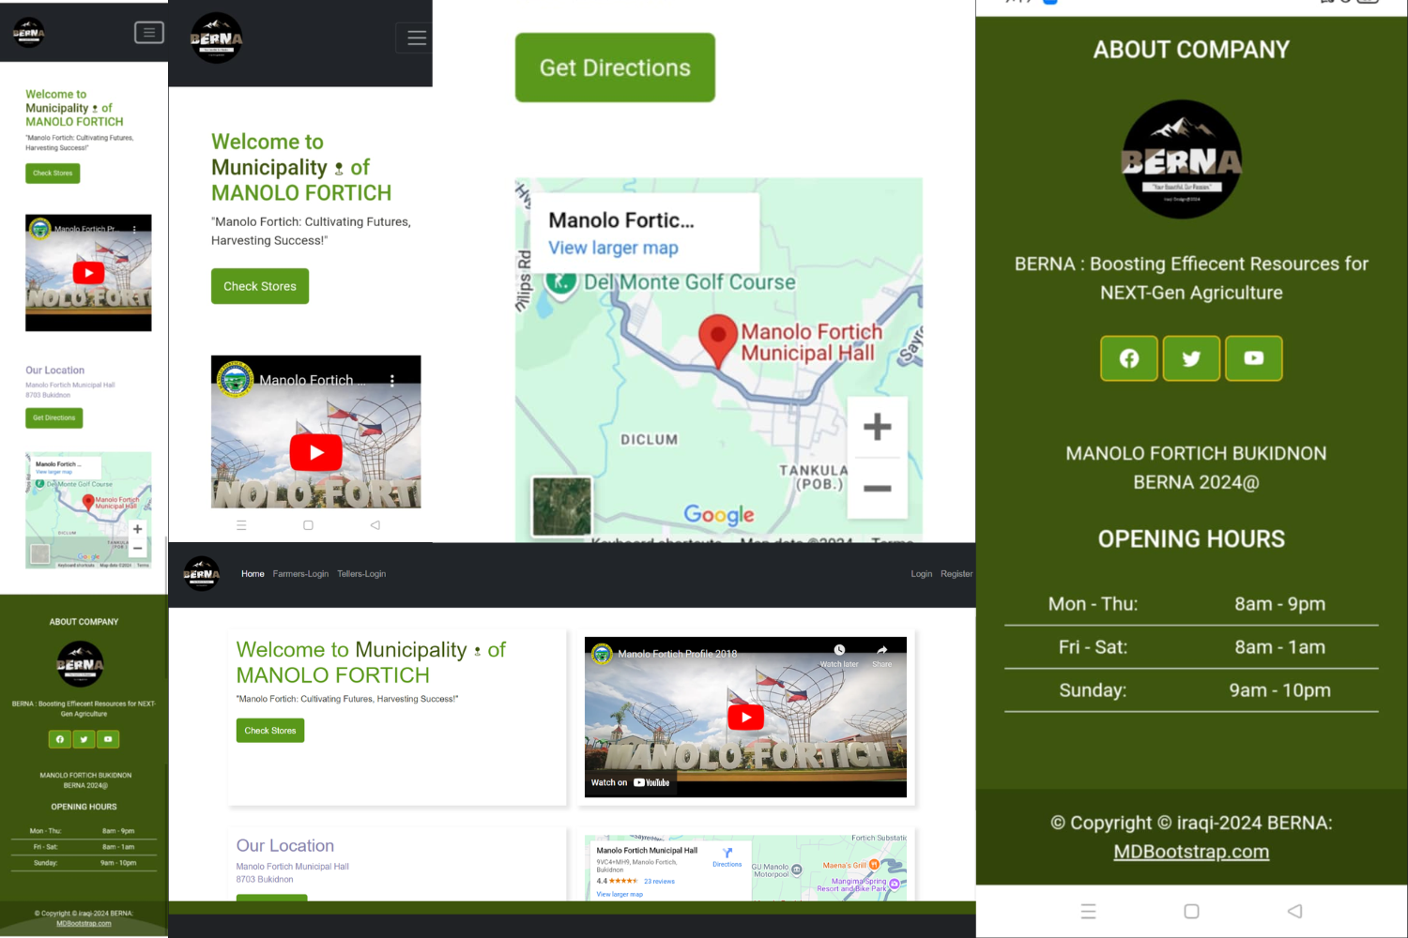

Figure 12.MFM-E-SYSTEM Main Landing Page

As shown in Figure 12 as part of testing and briefing, the main landing page of MFM-E-SYSTEM, Displayed in Mobile and desktop View, where users can view a video presenting Manolo Fortich Bukidnon, a MAP where MAO office is located, this Map is for Farmers who wants to be part of the program and don't know the location of the MAO office in Manolo Fortich Municipality.

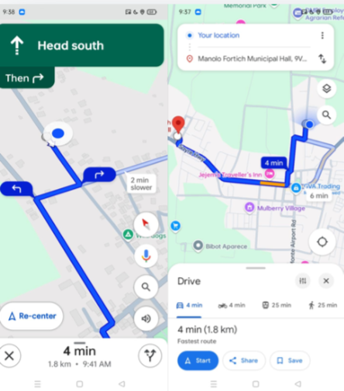

Figure 13. Map features in MFM-E-SYSTEM

As shown in Figure 13 as part of testing and briefing, in the Map users can be guided by the Map features in the system, the Map will give directions, distance and possible time arrival on the destination set in the system depending on the means of transportation used.

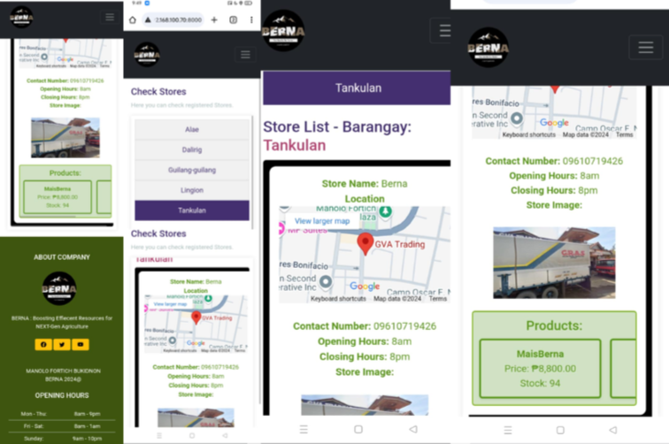

Figure 14. MFM-E-SYSTEM Store’s page

As shown in Figure 14 as part of testing and briefing, in the Check Store button in the landing page, when click users will be directed into the store page, this store page has a list of stores that are registered in the program filtered by barangays where the store is located Each Stores has Map, it contains also the the features in figure 13, Also Users can view in this page the available products, price and stocks quantity per product to help them made a decision which store they go to buy what they need.

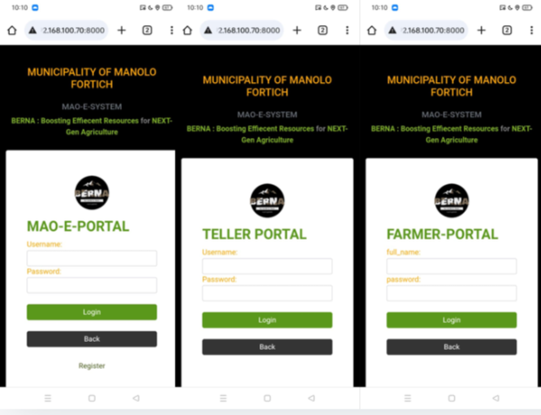

Figure 15. MFM-E-SYSTEM users portal

As shown in Figure 15 as part of testing and briefing, is the portals of MFM-E-SYSTEM. Main Admin and Sellers portal, store-staff Portal for the store-staff in each Store, and lastly the Farmers Portal.



Figure 16. MFM-E-SYSTEM Farmers-Dashboard

As shown in Figure 16 as part of testing and briefing, is the Farmer-Dashboard, where farmers can view their profile and get their QR-CODE to be used in purchasing agriculture needs for their farms, this QR-CODE if verified will grant farmers a discount on every purchase they made. Also it has buttons to make them print or download.

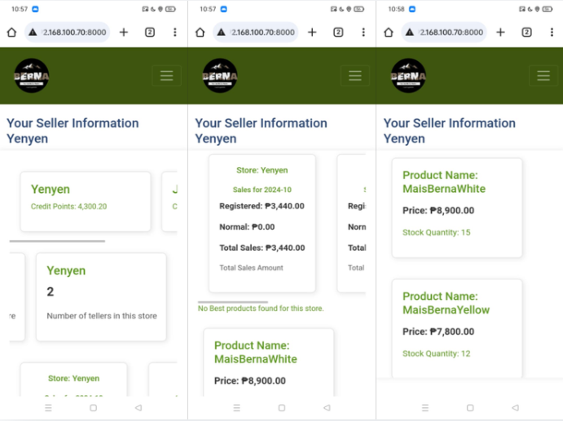

Figure 17. MFM-E-SYSTEM Sellers-Dashboard

As shown in Figure 17 as part of testing and briefing, is the Sellers-Dashboard, where sellers can view their Store Informations like, Credit Stores for every Store branches they have, top 2 best-seller products per branch, low-stocks product per branch, employee or store-staff per branch, and monthly total sales for each branch.

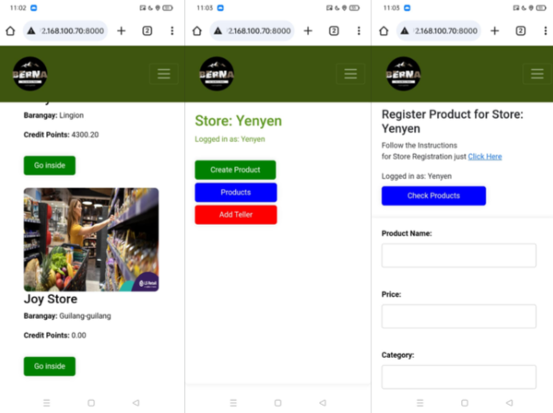

Figure 18. MFM-E-SYSTEM Sore Page for sellers

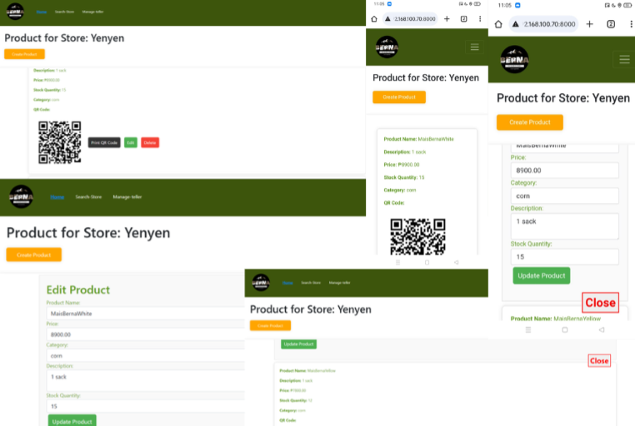

Figure 19. MFM-E-SYSTEM Product Management Page

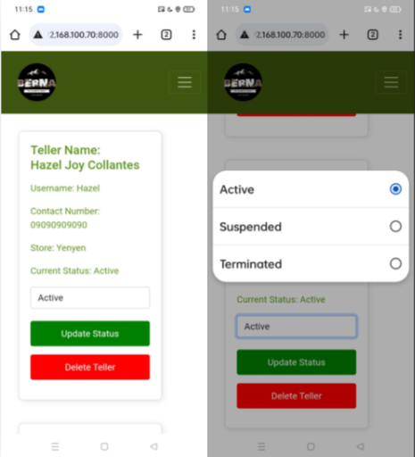

Figure 20. MFM-E-SYSTEM store-staff Management Page

As shown in Figure 18, 19 and Figure 20 as part of testing and briefing, is the Seller's-Stores or Branches, where sellers can view their Stores , Inside each Store they can Manage Product, Manage store-staff,

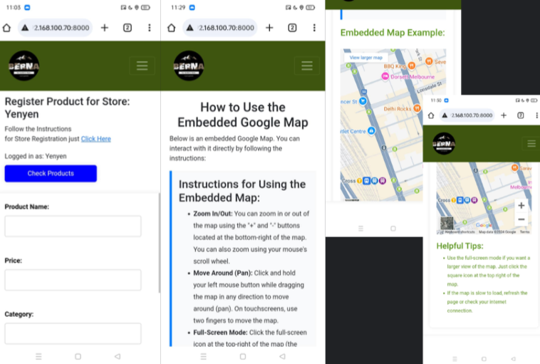

Figure 21. MFM-E-SYSTEM Seller's Registration Page

As shown in Figure 21 as part of testing and briefing, is the Seller's-Store Registrations page where sellers can register their Stores , Inside it has instructions on how to register Store.

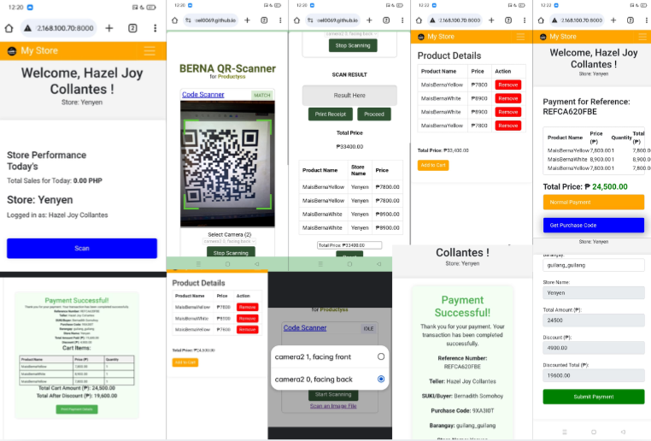

Figure 22. MFM-E-SYSTEM store-staff Pages

As shown in Figure 22 as part of testing and briefing, is the store-staff Page, here store-staff can scan products QR-CODES to add to automatic calculate and add to cart, it can also remove carts, then when proceeding to payment, farmer can scan the Farmers QR-CODE to verify, when verified farmers will benefit a purchase discount as seen in figure 22, after the transactions is done it will shows a Thank you page and a print a purchase receipt.

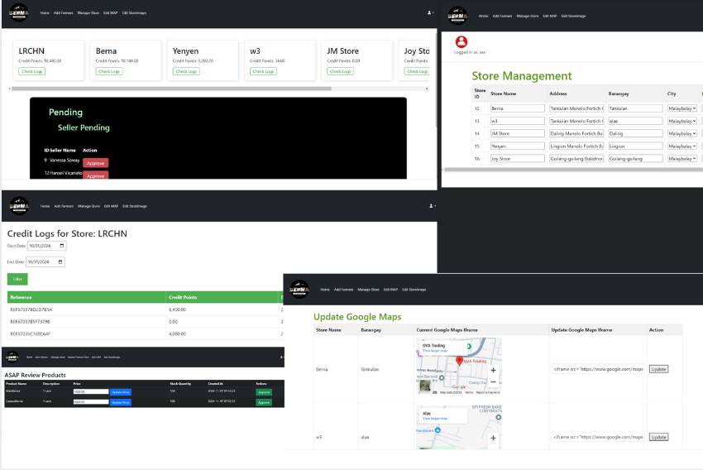

Figure 23. MFM-E-SYSTEM Admin Pages

As shown in Figure 23 as part of testing and briefing, the Admin page, here can see every store registered in the program credit points from the highest to lowest credit points, it can also view the credit points breakdown and print reports for each store. admin can also manage the store information, review and update products set by the stores.

*Pictorials*

After the actual presentation, the researchers conducted the pictorials for the documentation as shown below in Figure 24.



Figure 24. Finished Presentation Pictorials

**Evaluation**



Figure 25. Gathering of Feedback through Evaluation

The evaluation portion is to determine the feedback of the users and keep assured on the quality of the final output. System Portability Scale (SPS), System Reliability Scale(SRS), and System Usability Scale (SUS) is used for the system evaluation given to the participants. The researchers let the (206) respondents of Manolo Fortich Farmers 4 Barangays Gilang-gilang, Ligi-on, Maluko and Tankulan try out the MFM-E-SYSTEM web application and gathered the feedback by letting the respondents answer the prepared research instrument. The researchers used the Likert Scale in interpreting the data gathered.

**3.6.1 Evaluation Tool**

The performance of the system was assessed to see whether it complied with System System Portability Scale (SPS), System Reliability Scale(SRS), and System Usability Scale (SUS) Standards.

A likert scale is a method for converting quantitative values into qualitative values in order to perform the best statistical analysis. It is commonly used to assess attitudes, knowledge, perceptions, values, and behavioral changes. A Likert-type scale consists of a series of statements from which respondents can select in order to rate the user responses to evaluative questions (Vogt, 1999). The researchers used the Likert Scale to interpret the result and overall average of the System Portability Scale (SPS), System Reliability Scale(SRS), and System Usability Scale (SUS) Standards.

**Formula:**   
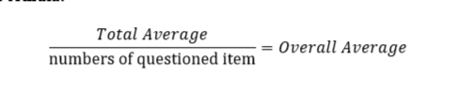

Table 5. Likert Scale Table

| **SCALE** | **PARAMETERS** | **VERBAL INTERPRETATION** |
| --- | --- | --- |
| 5 | 4.20 – 5.00 | Excellent (E) |
| 4 | 3.40 – 4.19 | Very Good (VG) |
| 3 | 2.60 – 3.39 | Good (G) |
| 2 | 1.80 – 2.59 | Fair (F) |
| 1 | 1.00 – 1.79 | Poor (P) |

**3.6.2 Distribution of Respondents**

Table 6 shows the total number of respondents. (31) farmers from Barangay Tankulan, (132) farmers from Barangay Guilang-guilang, (35) farmers from Barangay Maluko, (2) farmers from Barangay Lingi-on. (3) store-staff from Barangay Guilang-guilang, (1) seller from Barangay Guilang-Guilang, (1) seller from Barangay Tankulan, and (1) seller from Barangay Dahilayan In total, there were (206) individuals who evaluated the MFM-E-SYSTEM.

Table 6. Distribution of Respondents

| **Respondents** | **No** | **Percentage** |
| --- | --- | --- |
| Barangay Tankulan Farmers | 31 | 15.04% |
| Barangay Guilang-guilang Farmers | 132 | 64.07% |
| Barangay Maluko Farmers | 35 | 16.99% |
| Barangay Lingi-on Farmers | 2 | 0.97% |
| Barangay Guilang-Guilang  Store-Staff | 3 | 1.45% |
| Seller, Guilang-Guilang | 1 | 0.48% |
| Seller, Tankulan | 1 | 0.48% |
| Seller, Dahilayan | 1 | 0.48% |
| **TOTA**L | 206 | 100% |

CHAPTER 4

**RESULTS AND DISCUSSIONS**

**4.1 SPS, SRP and SUS RESULT**

Table 7 shows the usability of the prototype system. The result has a weighted mean of 3.755 which means that the usability of the application is “Very Good (VG)” based on Likert Scale verbal interpretation.

Table 7. Usability

| **Characteristics** | **Sub-Characteristics** | **Mean** | **Verbal Interpretation** |
| --- | --- | --- | --- |
| Usability | 1. Appropriateness  Recognizability | 3.75 | Very Good (VG) |
| 2. Learnability | 4.73 | Excellent |
| 3. Operability | 4.25 | Very Good (VG) |
| 4. Use Error Protection | 3.75 | Very Good (VG) |
| 5. User Interface Aesthetics | 4.73 | Excellent |
| 6. Accessibility | 3.75 | Very Good (VG) |
| **Weighted Mean** | | 4.10 | Very Good (VG) |

Table 8 shows the reliability of the prototype system. The result got a weighted mean of 4.0025 which means that the reliability of the prototype system is “Very Good (VG)” based on Likert Scale verbal interpretation.

Table 8. Reliability

| **Characteristics** | **Sub-Characteristics** | **Mean** | **Verbal Interpretation** |
| --- | --- | --- | --- |
| Reliability | 1. Maturity | 4.31 | Excellent |
| 2. Availability | 3.87 | Very Good (VG) |
| 3. Fault Tolerance | 3.73 | Very Good (VG) |
| 4. Recoverability | 4.10 | Very Good (VG) |
| **Weighted Mean** | | 4.00 | Very Good (VG) |

Table 9 shows the Portability of the prototype system. The result has a weighted mean of 4.670 which means that the portability of the prototype system is “Excellent” based on Likert Scale verbal interpretation.

Table 9. Portability

| **Characteristics** | **Sub-Characteristics** | **Mean** | **Verbal Interpretation** |
| --- | --- | --- | --- |
| Portability | 1. Adaptability | 4.51 | Excellent |
| 2. Installability | 4.77 | Excellent |
| 3. Replaceability | 4.73 | Excellent |
| **Weighted Mean** | | 4.67 | Excellent |

**4.2 Overall Result**

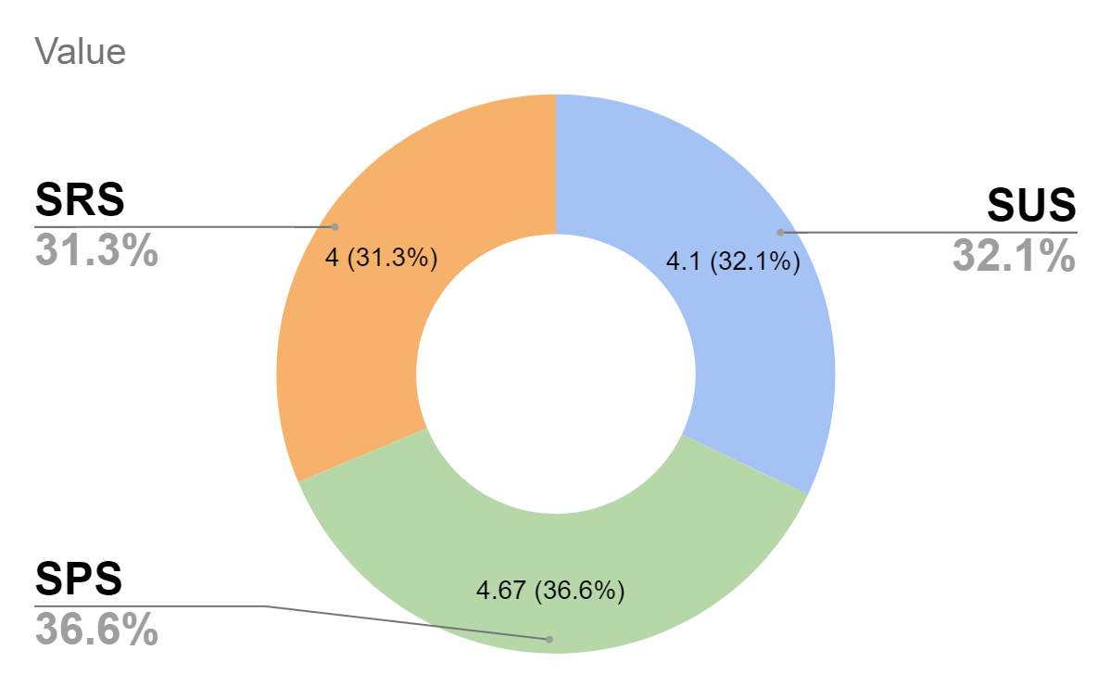

Figure 25. Overall Quality Testing Graphical Representation

In summary, Figure 25 shows the graph of the Overall Quality Testing that was provided on the System Portability Scale (SPS), System Reliability Scale(SRS), and System Usability Scale (SUS) evaluation which concludes that the feedback left during the actual presentation was a positive outcome. As a result, the overall average satisfaction rated as 4.26 or equivalent to “Excellent” which means that the users found the implementation of a MFM E-System: QR Code Verification of points calculation for tax deduction and Discount Management of Manolo Fortich is functional and beneficial to them

CHAPTER 5

**SUMMARY OF FINDINGS,**

**CONCLUSIONS AND RECOMMENDATIONS**

This chapter summarizes the findings of the study and provides conclusions and recommendations of the Design and Development of Web-Based MFM E-System: QR Code Verification of Points Calculation for Tax Deduction and Discount Management of Manolo Fortich.

**5.1 Summary of Findings**

This study has designed and built a Design and Development of Web-Based MFM E-System: QR Code Verification of Points Calculation for Tax Deduction and Discount Management of Manolo Fortich. The respondents of the study were (31) Farmers from Barangay tankulan, (132) Farmers from Barangay Guilang-guilang, (35) Farmers from barangay Maluko, (2) Farmers from Barangay Lingion, (3) Tellers from Barangay Guilang-guilang, (1) Seller from Guilang-guilang, (1) Seller from Tankulan, and Seller from Dahilayan. The researchers successfully designed the necessary requirements for developing the web application through the use of System Design Architecture for the operational mode on how it works, and Use-Case Diagram to depict user’s possible interaction with the application. The developed web application was evaluated by the users using the System Portability Scale (SPS), System reliability Scale (SRS), and System Usability Scale(SUS) evaluation which concluded the feedback left during the actual presentation was a positive outcome. As a result, the overall average satisfaction rate as 4.26 or equivalent to “Excellent” which means that the implementation of of a MFM E-System: QR Code Verification of Points Calculation for Tax Deduction and Discount Management of Manolo Fortich is functional and beneficial to them.

**5.2 Conclusion**

The study was successful in gathering sufficient data for the Design and Developing a Web-Based MFM E-System: QR Code Verification of Points Calculation for Tax Deduction and Discount Management of Manolo Fortich. Data required to achieve the research objectives, designing and developing a Web-Based MFM E-System, testing the Web-based MFM E-System using System Portability Scale (SPS), System reliability Scale (SRS), and System Usability Scale(SUS), evaluating the results from the deployed Web-Based MFM E-System Content Navigation System the data collected allowed the researchers to conclude that the to Design and Develop a Web-Based MFM E-System: QR Code Verification of Points Calculation for Tax Deduction and Discount Management of Manolo Fortich**.**

**5.3 Recommendation**

For the future researchers the panel is recommending the improvement of appealing designs, online hosting domain name, product automatic detection of category and a full store inventory.

**CHAPTER 5**

**SUMMARY OF FINDINGS,**

**CONCLUSIONS AND RECOMMENDATIONS**

This chapter summarizes the findings of the study and provides conclusions and recommendations of the Design and Development of Web-Based MFM E-System: QR Code Verification of Points Calculation for Tax Deduction and Discount Management of Manolo Fortich.

**5.1 Summary of Findings**

This study has designed and built a Design and Development of Web-Based MFM E-System: QR Code Verification of Points Calculation for Tax Deduction and Discount Management of Manolo Fortich. The respondents of the study were (31) Farmers from Barangay tankulan, (132) Farmers from Barangay Guilang-guilang, (35) Farmers from barangay Maluko, (2) Farmers from Barangay Lingion, (3) Tellers from Barangay Guilang-guilang, (1) Seller from Guilang-guilang, (1) Seller from Tankulan, and Seller from Dahilayan. The researchers successfully designed the necessary requirements for developing the web application through the use of System Design Architecture for the operational mode on how it works, and Use-Case Diagram to depict user’s possible interaction with the application. The developed web application was evaluated by the users using the System Portability Scale (SPS), System reliability Scale (SRS), and System Usability Scale(SUS) evaluation which concluded the feedback left during the actual presentation was a positive outcome. As a result, the overall average satisfaction rate as 4.26 or equivalent to “Excellent” which means that the implementation of of a MFM E-System: QR Code Verification of Points Calculation for Tax Deduction and Discount Management of Manolo Fortich is functional and beneficial to them.

**5.2 Conclusion**

The study was successful in gathering sufficient data for the Design and Developing a Web-Based MFM E-System: QR Code Verification of Points Calculation for Tax Deduction and Discount Management of Manolo Fortich. Data required to achieve the research objectives, designing and developing a Web-Based MFM E-System, testing the Web-based MFM E-System using System Portability Scale (SPS), System reliability Scale (SRS), and System Usability Scale(SUS), evaluating the results from the deployed Web-Based MFM E-System Content Navigation System the data collected allowed the researchers to conclude that the to Design and Develop a Web-Based MFM E-System: QR Code Verification of Points Calculation for Tax Deduction and Discount Management of Manolo Fortich**.**

**5.3 Recommendation**

For the future researchers the panel and stackholders is recommending the improvement of appealing designs, online hosting domain name, product automatic detection of category and a full store inventory, and also more crops covered, not only focus on crops like corn and cassava,

**References**

Amin, I. H. A., Lusiana, V., Hartono, B., & Wahyu, D. (2024). QR code-based attendance system for contact tracking post-pandemic. CogITo Smart Journal, 10(1), 436–450. https://doi.org/10.31154/cogito.v10i1.490.436-450

Ataelfadiel, M. a. M. (2022). E-authentication system using QR code & OTP. International Research Journal of Innovations in Engineering and Technology, 6(9), 75–81. https://doi.org/10.47001/irjiet/2022.609012

Bansal, S., & Gangopadhyay, S. (2003). Tax/subsidy policies in the presence of environmentally aware consumers. Journal of Environmental Economics and Management, 45(2), 333–355. https://doi.org/10.1016/s0095-0696(02)00061-x

Barnedo, E. D. C., & Inocencio, A. B. (2021). Impact of subsidies on market competition in the Philippine agriculture and manufacturing sectors. Philippine Journal of Science. https://openurl.ebsco.com/EPDB%3Agcd%3A7%3A6575847/detailv2?sid=ebsco%3Aplink%3Ascholar&id=ebsco%3Agcd%3A153380832&crl=c

Bestari, P. (2018). Understanding local government system through e-tax system. IOP Conference Series: Earth and Environmental Science, 145, 012095. https://doi.org/10.1088/1755-1315/145/1/012095

Chinyere, J. O., & Ikoromamsoma, E. (2021). Data management system and organizational efficiency of deposit money banks in Port Harcourt, Rivers State. Nigerian Journal of Management Sciences, 22(2), 38–54.

Dewi, I. A., Miftahuddin, Y., Fattah, M. A., Palenda, C. B., & Erawan, S. F. (2021). Point of sales system in in-home café website using agile methodology. Journal of Innovation and Community Engagement, 1(1), 01–19.

Elmetwaly, N. (2010). Proposed movement tracking e-systems of payment in the municipalities. Journal of Computer Science, 6(5), 572–575. https://doi.org/10.3844/jcssp.2010.572.575

Haibo, L., Jianlin, Q., Chaoping, Y., Xiang, H., Yun, Y., & Yu, L. (2018). Method for performing value added tax invoice check and authentication on the basis of invoice QR code scanning. SciSpace - Paper. https://typeset.io/papers/method-for-performing-value-added-tax-invoice-check-and-15azdaw1l8

Jin, J. H. (2014). Smart management systems based on QR codes for the reference mark. SciSpace - Paper. https://typeset.io/papers/smart-management-system-be-based-on-qr-code-for-the-171r2098cr

Kamble, N. M. S., Kendre, N. M. P., Siddiqua, N. M. A., & R, N. M. D. G. (2023). E-authentication system using QR code and OTP. International Journal of Advanced Research in Science Communication and Technology, 24–28. https://doi.org/10.48175/ijarsct-14204

Kambivi, H., Junirianto, E., & Fadhliyah, N. R. (2020). Development of inventory management application points of sale using Laravel. Tepian, 1(1), 9–17.

Khudadad, M., Motla, Y. H., Asghar, S., Anwar, S. A., & Iqbal, Z. (2014). A scrum-based framework for the e-agriculture system. https://doi.org/10.1109/inmic.2014.7097324

Mhetre, N., Rajak, P., Deshmukh, S., Khutale, S., & Pitambare, M. (2023). E-ration distribution system based on QR code. International Journal for Research in Applied Science and Engineering Technology, 11(5), 5459–5462. https://doi.org/10.22214/ijraset.2023.52366

Marico, J., Purnama, J., & Galinium, M. (2021). Analysis of open-source solution for point of sales inventory management system. In Conference Series (Vol. 3, No. 2, pp. 419–431).

Okeke, A. (2021). *Agile methodology: Meaning, advantages, disadvantages, and more*. Target Trend. https://targettrend.com/agile-methodology-meaning-advantages-disadvantages-more

Panda, S. K., Mohammad, G. B., Nandan Mohanty, S., & Sahoo, S. (2021). Smart contract-based land registry system to reduce frauds and time delay. Security and Privacy, 4(5), e172.

Qi, W., Sun, M., & Hosseini, S. R. A. (2023). Facilitating big-data management in modern business and organizations using cloud computing: A comprehensive study. Journal of Management & Organization, 29(4), 697–723.

Salazar, R. V. G., Fernández-Bedoya, V. H., Fretell, W. G. I., Mayuri, E. E. C., & Ruiz, M. A. Y. (2023). Electronic invoicing: A cross-sectional study of its implementation in micro and small businesses in Lima, Peru. F1000Research, 12, 189. https://doi.org/10.12688/f1000research.128317.1

Shinde, P., Shukla, K., Zagade, S., & Kumbhar, V. S. (2019). E-rationing management system. International Journal of Research in Advent Technology, 7(1), 361–363. https://doi.org/10.32622/ijrat.71201959

Suteja, B. R., Imbar, R. V., & J, M. C. (2020). E-certificate system based on portable document format and QR code for academic activities. SciSpace - Paper. https://typeset.io/papers/e-certificate-system-based-on-portable-document-format-and-11o43pkf26

Tubongbanua, J. B. P., Dahilan, K. M. V., Sagun, K. G. A., & Ruiz, J. L. (2017).

Wang, J., Dong, J., Li, L., & Wang, Y. (2010). Design and implementation of an integrated office automation/geographic information system rural e-government system. SciSpace - Paper. https://typeset.io/papers/design-and-implementation-of-an-integrated-office-automation-h5l1lf35ft

Wei, Z. (2018). QR code verification method and system. SciSpace - Paper. https://typeset.io/papers/qr-code-verification-method-and-system-10xpz557w

Yang, Q., Feng, B., & Song, P. (2008). Research on agricultural e-commerce public trade platform system. In Springer eBooks (pp. 933–942). https://doi.org/10.1007/978-0-387-77253-0_24

Zifceac, A. (2011). Agriculture with less bureaucracy. Bulletin of University of Agricultural Sciences and Veterinary Medicine Cluj-Napoca Horticulture, 68(2), 253–258. https://doi.org/10.15835/buasvmcn-hort:7129